Hazelbank Primary School

Social Media Policy
Oct 2023

Introduction

At Hazelbank Primary School, we wish to uphold a positive image with all stakeholders: pupils, staff, parents, governors, and community members. We strive to create an environment where there is mutual respect, where each person is valued as an individual and pastoral care is an integral part of education. Each pupil will be encouraged to fulfil his or her moral, intellectual, spiritual, physical, social, artistic, and emotional potential.

Use of ICT allows pupils to gain confidence and ability in an ever-changing society and prepares them for the challenges of a rapidly developing and evolving technological world. Through using ICT we aim to:

- Raise levels of pupil competence and confidence in Using ICT by developing pupils’ knowledge, understanding and skills in using a range of ICT tools to extend and enhance learning experiences across the curriculum.
- Raise levels of teacher competence and confidence in integrating ICT into their planning, teaching and assessment of pupils’ work (using ICT as an integral part of the processes and management of learning and teaching);
- Enhance and enrich children’s learning and add to its enjoyment.
- Ensure all learners have access to a range of new technologies and programs, including electronic sources of information and interactive learning resources.
- Enable children and teachers to have access to immediate and up-to-date sources of information,
- Develop children’s independent learning skills and collaboration skills using ICT across the curriculum.
- Develop information handling and research skills.
- Educate children to recognise the benefits of using the Internet.
- Educate the children to recognise the importance of Online Safety, and in how to keep themselves safe online.
- Educate the children to recognise and demonstrate acceptable online behaviour.

Social Networking

Social networking is everywhere. It is common to find parents, children, co-workers, and others on such sites. With social networks people across the world have access to tools and options that were previously non-existent. Whilst this allows many new opportunities to connect there are also potential dangers. It is a platform where almost anybody can see what we are doing. Whilst tagging photos of friends or posting comments, it can be easily overlooked that someone else who has been invited onto a social networking site can also view them. Often there is a minimal amount of control over who ultimately gets to see items posted.

It is important to remember that once something appears on the internet, it is almost impossible to remove. As these sites continue to grow in popularity, so too does the value of the information on them to parties other that those directly involved. Social networking users need to reflect what they are posting onto the internet.

While recognising the benefits of social networks for new and exciting forms of communication, this policy sets out the principles that pupils are expected to follow when using social media. Our Online Safety and Acceptable Use of the Internet and Related Technologies policies also inform this Policy.

This Policy applies to personal web space such as social networking sites on, for example (but not limited to), Facebook, Instagram, Snap Chat, Blogs, Twitter, chatrooms, forums, podcasts, social bookmarking sites and content sharing sites such as Flickr and YouTube.

The internet is a fast-moving technology, and it is impossible to cover all circumstances or be aware of all the latest forms of emerging media and platforms. This Policy covers the use of existing and any future social networking platforms.

Guidelines for pupils

“Respect for yourself and consideration for others” is key:

- Pupils must not use social media and the internet in any way to attack, insult, abuse or defame other pupils or any member of staff.
- Pupils must not use social media in a way that brings disrespect to our school.
- Photographs, videos or any image of pupils, staff or any member of our school community must not be published on a personal or public web space without prior permission from the school.
- Pupils and the wider school community should not post images or videos from school trips on any social media site.
- Social network sites should never be accessed within school.
Failure to follow these guidelines may result in disciplinary action, suspension, and possible exclusion from Hazelbank Primary School.

Guidelines for staff

It is possible that many staff will have their own social networking site accounts. It is important for them to protect their professional reputation by ensuring that they use their personal accounts in an appropriate manner:

- Staff must never add current pupils as friends into their personal accounts.
- Staff are strongly advised not to add past pupils as friends into their personal accounts until they are over the age of 18.
- Staff are strongly advised not to add parents of pupils they are teaching as friends into their personal accounts.
- Staff must not use social networking sites within lesson times for personal use.
- Staff need to use social networking in a way that does not conflict with the current GTCNI standards.
- Staff should review and adjust their privacy settings to give them the appropriate level of privacy and confidentiality.
- Posting derogatory comments about pupils, parents or colleagues is never acceptable. Staff are required to uphold the reputation of the school, to maintain reasonable standards in their own behaviour, and to uphold public trust in their profession.
- Staff may have legitimate reasons to use social network accounts to support learning in the classroom or, for example, to communicate with the sports team/author/artist etc. All social media uses must be approved by the ICT Co-ordinators and/or Principal in advance.

Inappropriate use of social networking by staff should be referred to the principal.

Guidelines for Parents/Guardians/Carers

Parents/Guardians/Carers should be aware of their responsibilities regarding the use of social networking:

- Parents/Guardians/Carers should not post pictures of pupils other than their own children on social networking sites.
- Parents/Guardians/Carers should make complaints through the official school channels rather than posting them on social networking sites as this can be detrimental and possibly damaging to the school community and, as such, are not beneficial to the children.
- Parents/Guardians/Carers should not post inaccurate, malicious or fictitious comments on social networking sites about any member of the school community, or any school policy, process or procedure.

Guidance/protection for pupils on using social networking.

To support the pupils of Hazelbank Primary School, and using guidance from the Department of Education, the Education Authority and outside agencies, members of staff will give clarity to pupils and parents/guardians/carers about the acceptable use of the internet and mobile devices by children whilst in Hazelbank Primary School.

Parents/Guardians/Carers have full responsibility for their child’s use of the internet, mobile devices, and social networks outside of school.

No pupils under 13 years of age should be accessing social networking sites.
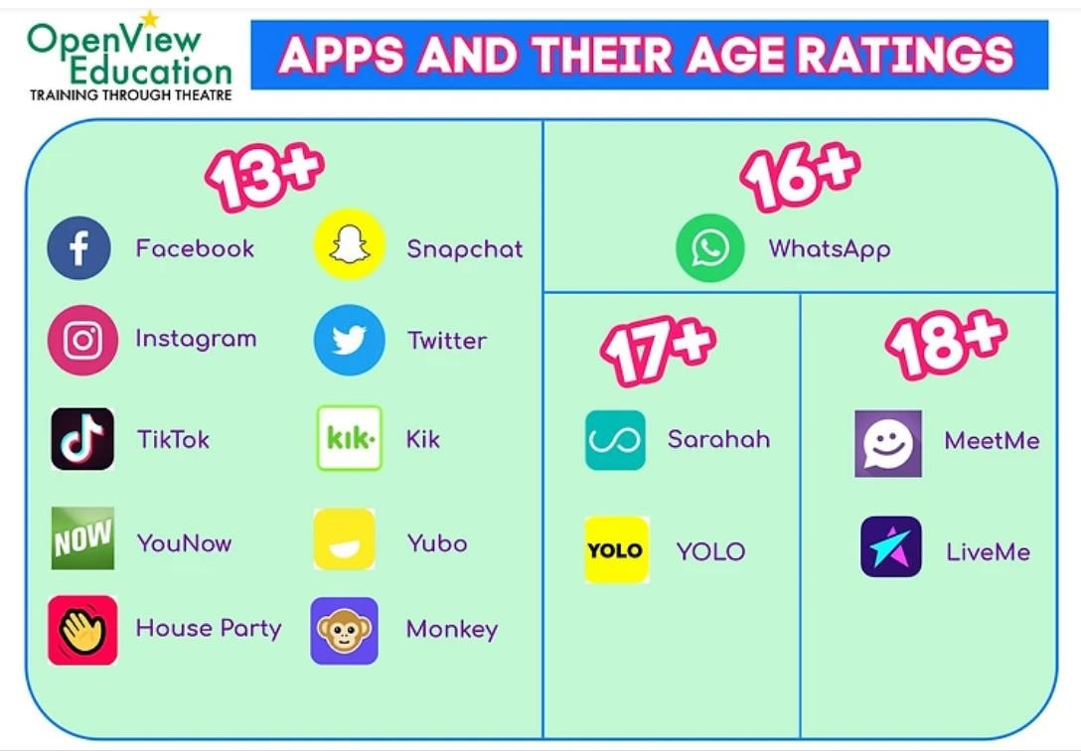

For further information please see our Online Safety and Acceptable Use of the Internet and Related Technologies Policies, on the school website www.hazelbankps.co.uk.

Dealing with incidents of online bullying/inappropriate use of social networking sites

The school’s Anti-Bullying Policy sets out the processes and sanctions regarding any type of bullying by a child in the school. No child is permitted to use a mobile phone during school hours and any use of computers is directly supervised by adults. Should a child use any form of technology to bully another child in school, the behaviour policy will be used to guide staff in dealing with the resolutions and consequences.

The school cannot and will not be held responsible in any way for the behaviour of pupils online or otherwise, outside of school hours (other than on trips and events agreed and supervised by us.) At these times it is strongly recommended that parents/guardians/carers monitor closely their child’s use of both online media and social media. Clearly, it can be helpful for parents to inform the school if there is an issue of inappropriate use of online/social media between pupils, so that the school can monitor closely any further behaviour that may need addressing. However, it is entirely the responsibility of the parents/guardians/carers to address inappropriate behaviour outside of school hours.

Procedures if the Social Media Policy is not adhered to

It is hoped that, in the interest, safety and well-being of all in the Hazelbank Primary School community, the Social Media Policy is followed. However, in the event of any breach of the Policy, appropriate procedures will be applied:

- If an image or video of a child is posted on a social network without the consent of the parent/guardian/carer, this a breach of our social media Policy. If this is brought to our attention, the poster will be contacted and asked to remove it immediately.
- In the event that any pupil or parent/guardian/carer of a child being educated at Hazelbank Primary School is found to be posting direct libellous or defamatory comments, or inappropriate comments in which a member of the school community can be identified from the content of the comment, on any social networking sites, they will be reported to the appropriate 'report abuse' section of the network site. All social networking sites have clear rules about the content which can be posted on the site, and they provide robust mechanisms to report contact or activity which breaches this. This may result in an account being removed.
- The Board of Governors of Hazelbank Primary School will take appropriate action to protect the school’s reputation and that of its staff, pupils and parents/guardians/carers, governors, and anyone else directly linked to Hazelbank Primary School.
- Where appropriate, comments will be reported to the PSNI. In serious cases or for repeat offences, the school will also consider further legal options to deal with any such misuse of social networking and other sites.
- Our school community takes the issue of cyber bullying very seriously. Any use by a member of the school community to publicly humiliate, embarrass or otherwise distress another by an inappropriate entry on a social networking site will be dealt with in accordance with our policies such as Anti-Bullying and/or Positive Behaviour, Parental Access to Staff and Ballymena Primary Principals’ Association’s Joint Guidance on Social Media Posting.
- Where it is found that there has been a breach of this policy by a staff member, an investigation will ensue, and this may result in disciplinary action being taken.

Hazelbank Primary School
Safeguarding and Child Protection

Code of Conduct regarding the Use of Social Media
This Code of Conduct applies to everyone within our school community.

Safeguarding and Child Protection is a key responsibility for everyone within our school community. An increasingly important aspect of Safeguarding and Child Protection concerns our use of social media. Below is a ‘Code of Conduct regarding the Use of Social Media’ that we expect all members of the school community (children, parents, staff, governors, and all regular visitors) to adhere to.

All online communications regarding the school are to be transparent and open to scrutiny. The Board of Governors will take appropriate action to ensure the safety and security of those within the school community and to protect the school’s reputation. Any breaches of this ‘Code of Conduct’ will be fully investigated.
- When using social media everyone has a responsibility to treat others within the school community with respect. Individuals must not make any derogatory, defamatory, rude, threatening, or inappropriate comments about anyone connected to the school. Offensive language should not be used.
- There must not be any postings on social media that links the school to any form of illegal conduct, or which might damage the reputation of the school.
- Confidential information regarding anyone within the school community must not be posted online. In relation to specific school activities, personal contact details including email addresses, home or mobile telephone numbers must not be made available online unless this has been agreed with the principal.
- Photographs or video clips of children completing activities in school must not be posted on social media by parents or children without the permission of the principal.
- The school’s name, logo or documents must not be posted online without the permission of the principal.
- Messages that compromise the security of the school premises must not be posted online.
- Where images or video clips of children are posted on the school website or other online facility endorsed by the school, children will only be names in accordance with their permissions form.
- Parents are responsible for their children’s use of social media outside of school. They should be aware of the age restrictions regarding all forms of social media, for example, Snapchat, Instagram, Facebook and WhatsApp state clearly that their registered users should be at least 13 years of age.
- Staff or volunteers working in the school must not use social media to communicate directly with children who attend the school.
- Staff must not use school ICT equipment to use social media without the permission of the principal.

Signed ……………………………………………………. Date …………………………………….
Chairperson Date of Review:

